Learnova

Digital Learning Hub

---------------------

Zainab Eman 22F-3738

Noor Fatima 22F-3634

Imama Kainat 22F3661

BSSE-3A

Contents

Learnova 1

Introduction: 1

Purpose: 1

Network Diagrams: 2

User Login: 2

User Register: 3

Register Course: 3

Contact Us: 3

In Conclusion: 4

Learnova

Introduction:

Learnova is an innovative online learning platform designed to enhance the student-teacher interaction, making education accessible, interactive, and efficient. Similar to Google Classroom, it allows students to take courses, engage with instructors, and provides features for course registration, profile updates, and more. This document will provide an overview of Learnova's web design, emphasizing its purpose and structure through a hierarchical diagram.

Purpose:

Learnova serves as a digital Platform for students and teachers, offering the following key features:

* Online Courses: Students can access and take courses on various subjects.
* Interaction: The platform enables students to interact with teachers, ask questions, and participate in discussions.
* Course Registration: Users can explore and register for courses based on their interests and academic needs.
* Teacher Search: Students can find teachers, view their profiles, and see the courses they offer.
* Profile Management: Users have the option to update their profiles for personalization.
* Contact Us: A contact form is available for inquiries, with contact information provided for additional communication.
* About Us: Learnova's vision and objectives are explained in detail.

Network Diagrams:

The network diagrams illustrates the structure and flow of Learnova's web pages.

## User Login:

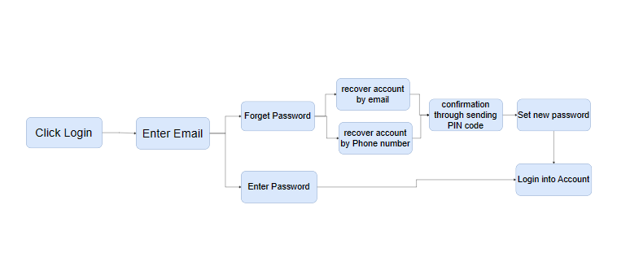

## User Register:

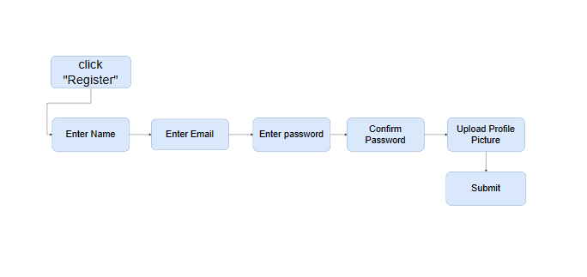

## Register Course:

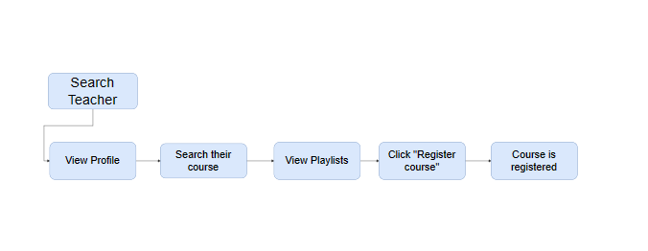

## Contact Us:

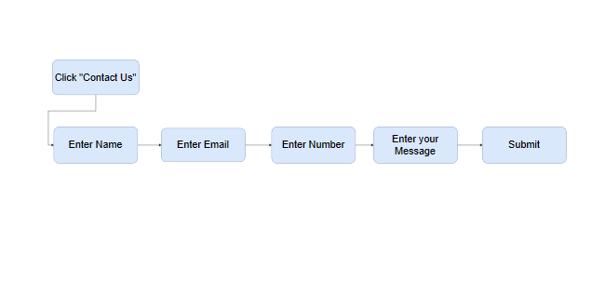

# In Conclusion:

Learnova is a user-friendly and interactive online learning platform that simplifies the process of accessing courses and engaging with instructors. The network diagrams serves as a visual guide, helping users navigate the various pages, functionalities and features available on the website. With its user-centric design and comprehensive educational tools, Learnova aims to provide an enriching learning experience for all its users.